Went through all three AI passes in your doc, layered in what "college project" and "team of 3" actually change, and re-checked the load-bearing claims against what's true right now instead of when that research was compiled. One idea clears the bar cleanly. Scorecard first, then the full stress-test. 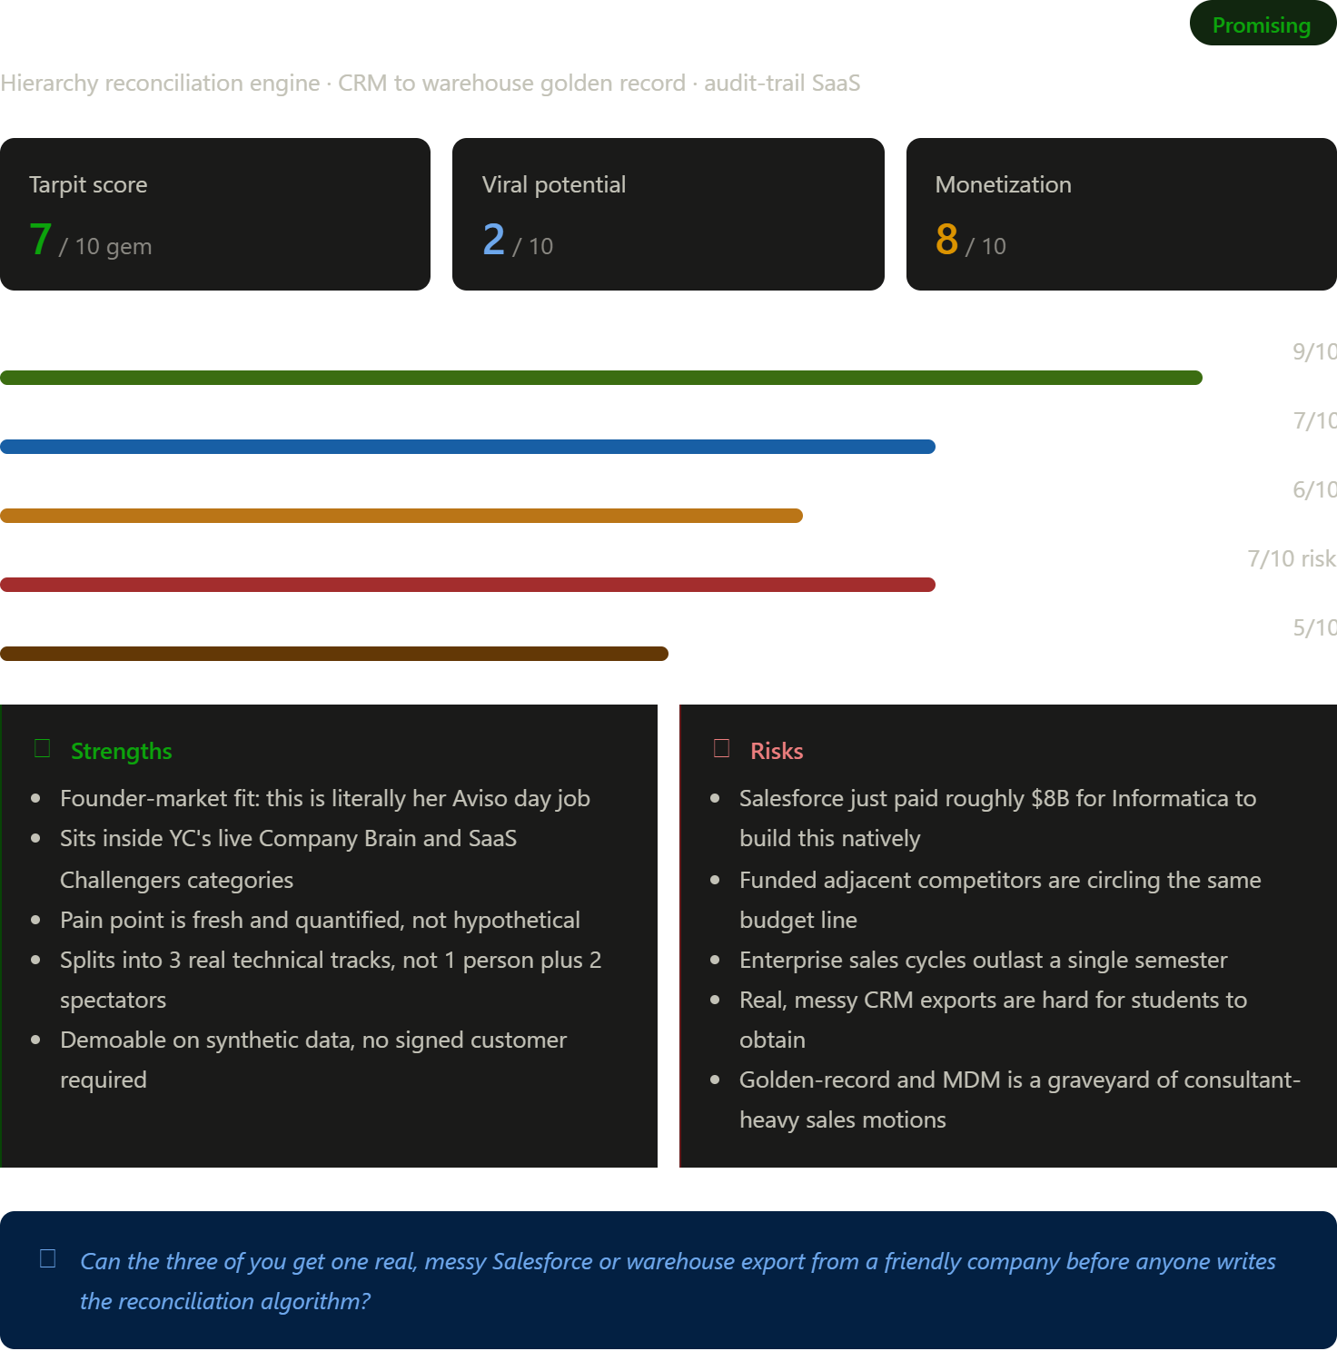
Working assumption, since you didn't specify: a generalist 3-person CS team, no one already a security or compliance specialist. That's what ruled the gateway and the payroll idea down a notch — flag it if I'm wrong.
🧲 Tarpit score
Promising (7/10). Real, quantified pain; a named YC category that's genuinely live right now, not inferred; founder-market fit about as strong as a college team can credibly claim. What keeps it out of Gem territory: since that research was compiled, the two biggest players adjacent to this exact space made very large, very public moves — see Cons. The competitive floor has risen since the doc was written.
🔍 What the idea actually is
Working name: Canon (placeholder — check trademark before you get attached). A reconciliation engine sitting between a company's CRM (Salesforce, HubSpot) and its warehouse (Databricks, Snowflake — wherever the "real" org chart, territory map, or account hierarchy actually lives), which finds where the two disagree, proposes a resolution via an AI agent, and logs every change to an audit trail.
- Value prop: turns "why doesn't the CRM match what finance is using" from a recurring fire drill into a continuously reconciled, explainable process.
- Target customer: RevOps / Sales Ops leads at Series B–D B2B SaaS companies running Salesforce or HubSpot on top of a modern warehouse — the same profile as your Aviso world, one org size up.
- Revenue model: B2B subscription to start, with room to move toward outcome pricing (per conflict resolved) once you have usage data to price against.
- Category: vertical AI infrastructure / data ops. Y Combinator's Summer 2026 Request for Startups lists fifteen categories, and both Company Brain and SaaS Challengers are on that list — this sits inside both.
✅ Pros
- Founder-market fit: this is your literal day job — Salesforce/Mongo hierarchy reconciliation at Aviso.
- YC partner Tom Blomfield describes Company Brain as pulling a company's scattered knowledge — chats, tickets, tribal memory — into one structured source that agents can actually execute against; a hierarchy golden-record is a direct instance of that thesis, not a stretch.
- The pain is current, not hypothetical: recent CRM audits find roughly three-quarters of records incomplete, with duplicate rates commonly running fifteen to twenty-five percent, and about a quarter of CRM admins report that less than half their data is accurate and complete.
- Gartner projects three-quarters of high-growth B2B companies will run a formal RevOps model by 2026 — the buyer role this sells into is becoming standard, not niche.
- Splits into three real, non-overlapping technical tracks (below) — an actual team project, gradeable per-person.
- Demoable on synthetic conflict data. You don't need a signed enterprise customer for a credible college eval or a credible YC application — 40% of accepted YC companies have zero revenue at application time per the doc's own research; what matters is a working thing with a growing usage number.
❌ Cons & structural risks
- The platform you'd sit on top of just built your feature. Salesforce agreed in May 2025 to acquire Informatica, an enterprise data-management company, in a deal worth roughly eight billion dollars in equity value. It closed in November 2025, and Salesforce was explicit that the point was folding Informatica's data catalog, governance, and master-data-management tooling into the CRM itself, to give agentic AI a trustworthy data foundation to act on. None of the three AI passes in your doc had this — it happened mid-flight. It's not fatal (more on why below), but it's the single biggest update since that research was written and it changes the wedge you should pitch.
- Funded adjacent competitors are already circling this budget line: Coffee.ai sells an agent that captures data directly into an existing Salesforce or HubSpot instance, and SyncGTM built its pitch around waterfall enrichment across dozens of providers to keep CRM records complete. Neither does hierarchy-specific reconciliation with an audit trail — but "nobody's building this" (the doc's framing) is no longer quite true; "nobody's building this specific thing" is the more honest claim now.
- Enterprise sales cycles outlast a semester. You will not close a paying Series B–D customer in 12–16 weeks. Plan the deliverable around a usage metric, not a signed contract.
- Real, messy CRM exports are hard for students to get — companies won't hand you production Salesforce data. You'll likely need a convincingly messy synthetic dataset, which risks the engine looking better than it would against real chaos.
- "Golden record" / MDM is a graveyard-heavy category historically won by expensive, consultant-driven enterprise sales motions, not lean product-led teams (see below).
🪤 Tarpit traps to watch for
- The signed-pilot delusion — gating team morale or scope on landing a paying customer inside the semester. You won't, and that's fine; a growing usage number is the actual bar.
- Building all four architecture pieces at once (connectors, reconciliation engine, agent layer, audit UI) before showing anyone anything. Scope to one hierarchy type, end to end, first.
- Building "the Informatica killer" instead of the neutral translation layer. That's a scope trap no three-person team wins. Your wedge is specifically the data that lives outside Salesforce's walls — see below.
- Treating the LLM agent as the moat. It isn't — any team can wrap an LLM. The moat is the hierarchy-specific conflict logic plus the audit trail. If the pitch leads with "AI-powered," you're underselling the actual differentiation.
- Polishing the dashboard over the reconciliation engine's correctness. For a capstone grade and for YC credibility, algorithmic correctness matters more than pixel polish.
⏳ Historical graveyard
- Informatica built the data-management category over three decades via exactly the expensive, services-heavy enterprise sales motion this idea needs to avoid. Salesforce paying roughly $8B for it is proof the pain is durable and valuable — and also proof the category has historically rewarded platform incumbents and systems integrators over lean startups.
- Tamr (MIT-born, founded on "AI-native" record matching and mastering years before that was a trendy pitch) never broke into fast product-led growth. It became a long-sales-cycle, services-adjacent enterprise vendor instead.
- The signal from both: the failure mode in this category isn't "no demand" — demand is real and growing. It's sales-cycle death: good technology, but the enterprise motion takes longer to mature than the runway lasts. For a college team the equivalent risk is spending the whole semester heads-down on the engine and never testing whether a real RevOps buyer would actually pay.
🚀 Where it could succeed
The sharpened wedge: position as the neutral, warehouse-native reconciliation layer for the GTM data that lives outside Salesforce's own walls — not a generic "CRM data quality" tool. Salesforce-owned Informatica has every incentive to keep the story "everything lives in Salesforce"; your story is "half your hierarchy truth lives in the warehouse, and that's the half nobody's reconciling neutrally." That's sharper than anything in the original three-AI research, and it's grounded in something that happened after that research was written.
Team split (this is where 3 > 1 actually matters):
- Person A — connectors: read-only Salesforce API + Databricks/Snowflake/Postgres warehouse connector, data normalization
- Person B — the algorithmic core: conflict detection, survivorship logic, and an LLM agent that proposes plain-English resolution rules
- Person C — product: React dashboard, diff view, one-click "propose fix," audit trail UI
Timing that actually lines up: the on-time deadline for YC's just-closed Fall 2026 batch was July 27, 2026, so that window's gone. But YC's deadline-to-batch-start gap has consistently run nine to ten weeks, which points to an unconfirmed Winter 2027 deadline landing somewhere around late October or early November 2026 — not officially published yet, but a reliable pattern. If your term runs roughly Aug/Sept through December, a working MVP by the end of the semester lands almost exactly on that window.
A rough semester map:
- Weeks 1–2: discovery, not code. Split up RevOps/Sales Ops interviews between the three of you (Pavilion, RevOps communities, LinkedIn). Proceed only if most people describe the pain unprompted and name a budget line.
- Weeks 3–8: build against synthetic data first, real data the moment you can get it. One hierarchy type, fully working, before adding a second.
- Weeks 9–12: get one friendly pilot, paid or not. Track a usage number weekly.
- Weeks 13–16: polish for the course deliverable and package the same artifact for an application.
💡 Things you may have missed
- The Informatica acquisition is a pitch line, not just a risk — "Salesforce just proved this problem is worth $8B; we're the neutral layer for the half of GTM data that lives outside their walls" is stronger positioning than anything in the original research, specifically because it's grounded in something none of the three AI passes could have known about.
- Your own university almost certainly has messy real hierarchy data behind the scenes — course-enrollment/advisor/department org charts, or a career-services CRM — that could be a low-stakes first "friendly" data source before you need an actual company.
- The earlier Claude doc's idea #4 (a narrower cut anchored to CRM migration events specifically) is a ready-made pivot if your discovery interviews find "we're mid-migration" is a sharper trigger than steady-state hygiene.
- None of the three prior analyses weighed team size at all — they were all written assuming a solo founder. A three-person technical team is a genuine positive signal worth naming explicitly in any application, not downplaying.
🎯 Verdict & recommendation
Yes, build it — with the sharpened wedge, not the generic one. It's the one idea in fifteen where a college team's real constraints (semester timeline, three sets of hands, no enterprise access, but real domain expertise) line up with what the idea actually needs. The one question to answer before anyone opens an editor: can the three of you get one real, even small, even messy Salesforce-or-warehouse export from a friendly company first — or are you about to design a reconciliation algorithm against data you're imagining?
A three-person, multi-service codebase like this — connectors, an agent layer, a dashboard — is exactly the kind of build that goes faster with an agentic coding tool splitting work across the repo.Say the word and I'll draft the semester project proposal, the discovery-call script for RevOps interviews, or a technical architecture doc first.

EXPLAIN THE PROBLEM IN SIMPLE WORDS?

The problem, in plain words:
Big companies keep two records of "who reports to whom" and "who owns which client." One lives in Salesforce (or HubSpot) — that's what sales reps and managers look at every day. The other lives in the company's data warehouse — the spreadsheet-of-record that finance, data teams, and leadership actually trust for numbers.
These two copies drift apart constantly. Someone gets promoted and Salesforce isn't updated. A territory gets reassigned in the warehouse but nobody tells the CRM. A rep leaves and their accounts get orphaned in one system but not the other. Multiply that across thousands of accounts and hundreds of employees, and you get a mess: wrong commission payouts, wrong sales forecasts, wrong "who owns this deal" answers — and nobody can say which version is actually true.
Right now, fixing this is manual. A data or ops person has to notice the mismatch, dig through both systems, guess which one is right, and fix it by hand. That's slow, error-prone, and never really "done" — it just breaks again next week.
The solution, in plain words:
Build a tool that automatically compares the two records, spots every place they disagree, and — using AI — suggests which one is probably correct and why (in plain English, not code). A human clicks "approve" instead of digging through spreadsheets. Every fix gets logged, so if someone asks "why does this account belong to this rep," there's a paper trail instead of a shrug.
Think of it like a spell-checker, but for a company's org chart and account ownership — it doesn't just flag "these don't match," it proposes the fix and remembers every correction it's made.
Why it's worth building: companies already know this problem costs them real money (bad forecasts, missed commissions, wasted rep time), and it's exactly the kind of "boring but valuable" AI tool that's getting funded right now — because it saves a company from hiring more people to do this by hand.

EXPLAIN THE PROBLEM IN SIMPLE WORDS WITH ANALOGY?

Let's use an engineering college analogy. Imagine your college has two official systems that are supposed to contain the same information, but they don't always stay in sync.

🎓 The Setting
Your engineering college has two databases:
📱 1. Student Portal (like Salesforce)
This is what students, class representatives (CRs), and faculty use every day.
It contains information like:
- Which faculty advisor you're assigned to
- Which project guide you're under
- Which club or lab you're a part of
📊 2. College Administration Database (Data Warehouse)
This is maintained by the administration and is used for:
- Official records
- Attendance reports
- Internal audits
- Placements
- Scholarships
- Department statistics
The administration trusts this database when making important decisions.

🚨 The Problem
Initially, both systems have the same data.
Example:
Student | Faculty Advisor
Vallabh | Dr. Rao
Both systems agree.

Now imagine...
Dr. Rao goes on sabbatical.
The department changes your advisor to Dr. Mehta.
But...
Only the Administration Database gets updated.
The Student Portal still says:
Faculty Advisor → Dr. Rao
Now the two systems disagree.

Another example
Your capstone project guide changes.
Student Portal says:
Guide → Prof. Sharma
Administration Database says:
Guide → Prof. Iyer
Which one is correct?
Nobody knows.

More problems happen...
Suppose:
- A professor resigns.
- Students get reassigned.
- Clubs change coordinators.
- Lab mentors change.
- Project groups get reshuffled.
Some updates happen in one system.
Some happen in the other.
Eventually you have hundreds of mismatches.

😬 Why is this bad?
Imagine placement season.
The placement office wants to know:
"Which faculty is responsible for Vallabh?"
Student Portal:
Dr. Rao
Administration:
Dr. Mehta
Now:
- Emails go to the wrong professor.
- Reports become inaccurate.
- Faculty workload calculations are wrong.
- Students miss important communications.
- Scholarship approvals get delayed.
Nobody knows which database is correct.

😓 Current Solution (Manual)
A department administrator notices the mismatch.
Now they have to:
Step 1:
Open Student Portal.
Step 2:
Open Administration Database.
Step 3:
Open old emails.
Step 4:
Check department circulars.
Step 5:
Ask professors.
Step 6:
Guess which system is correct.
Step 7:
Update one of them.
Repeat this hundreds of times.
Next week...
Someone changes another record.
The problem returns.

💡 Proposed AI Solution
Instead of waiting for humans...
An AI system continuously compares both databases.
It sees:
Student Portal
Vallabh
Advisor: Dr. Rao

Administration
Vallabh
Advisor: Dr. Mehta
Mismatch detected.

Instead of simply saying
"Mismatch found."
The AI thinks further.
It notices:
- Dr. Rao retired last month.
- 48 other students were moved to Dr. Mehta.
- Department circular mentions the reassignment.
- Administration database was updated yesterday.
- Student Portal hasn't been updated in 6 months.
So it concludes:
Dr. Mehta is probably correct (95% confidence).

Then it explains why in plain English.
Example:
I recommend updating the Student Portal because:
- Dr. Rao is no longer an active faculty advisor.
- Department reassignment records show Vallabh moved to Dr. Mehta.
- Similar updates have already been applied to other students.
No technical jargon.
Just an explanation a department administrator can understand.

👩‍💼 Human Approval
The administrator doesn't investigate from scratch anymore.
They simply see:
Mismatch

Student Portal:
Dr. Rao

Administration:
Dr. Mehta

AI Recommendation:
Update Student Portal

Confidence:
95%

Reason:
Department reassignment dated July 18.
They click:
✅ Approve
Done.

📝 Audit Trail
Months later someone asks:
"Why is Vallabh assigned to Dr. Mehta?"
Instead of saying
"I don't remember."
The system shows:
Change History

July 18
Advisor changed

Reason:
Department reassignment order

Approved by:
Academic Office

Suggested by:
AI
Everything is traceable.

📖 Think of it like Grammarly
Grammarly doesn't automatically rewrite everything.
It says:
"This sentence is probably incorrect."
Then suggests:
"Use this instead."
You click Accept.

This AI works similarly.
Instead of checking grammar, it checks college records.
It says:
"These two systems disagree."
Then recommends:
"Update the Student Portal because the administration database matches the latest department order."
You click Approve.

🏆 Why Companies) Would Want This
Without the AI:
- ❌ Staff spend hours comparing records manually.
- ❌ Mistakes are common.
- ❌ Important reports become unreliable.
- ❌ The same issues keep recurring.
With the AI:
- ✅ Mismatches are detected automatically.
- ✅ Likely corrections are suggested.
- ✅ Humans only review and approve.
- ✅ Every change is recorded with a clear explanation.
- ✅ Both systems stay synchronized over time.

One-line analogy
Think of it as an AI class representative (CR) who constantly checks whether the Student Portal and the Administration Office's records agree. Whenever they don't, the AI identifies the discrepancy, suggests the most likely correct information with a clear explanation, and asks the administrator for a quick approval instead of making them investigate everything manually.

HOW TO IMPLEMENT CANON?
Canon
Four-layer architecture:
- Connectors — pull data out of source systems
  - Salesforce connector: OAuth + REST/Bulk API (or simple-salesforce) pulling Account, User, Role, and hierarchy objects
  - Warehouse connector: Databricks/Snowflake read via SQL, pulling the equivalent hierarchy tables from the warehouse side
  - Both land into a common staging schema so downstream logic doesn't care where a record came from
- Reconciliation engine — the core logic
  - Normalize: map both sources' fields into one canonical schema (e.g. entity_id, parent_id, role_name, territory, last_modified, source_system)
  - Candidate generation: pair up records likely to represent the same entity across sources (exact key match first, fuzzy/embedding match for the rest)
  - Conflict detection: field-by-field diff on matched pairs — flag where CRM and warehouse disagree (different parent, different role, different territory)
  - Severity scoring: rule-based score per conflict (e.g. structural conflicts like wrong parent > cosmetic conflicts like name casing)
- Agent layer — the "agentic" part
  - A tool-using LLM agent receives each conflict record plus your configurable survivorship rules ("warehouse wins on territory," "most-recently-modified wins on role," etc.)
  - Agent proposes a resolution in plain English with its reasoning, tagged with a confidence score
  - Low-confidence or rule-ambiguous cases route to a human review queue instead of auto-resolving
- Audit trail + dashboard
  - Every proposal, whether auto-applied or human-reviewed, gets logged: what changed, who/what decided it, confidence, timestamp
  - Dashboard (this is the piece your non-technical teammates can own in something like Streamlit or a Claude/v0-generated React app): conflict queue, resolution history, drill-down per entity
Data model (core tables):
entities (entity_id, source_system, raw_fields JSON, last_modified)
matches (match_id, entity_id_crm, entity_id_wh, confidence)
conflicts (conflict_id, match_id, field, crm_value, wh_value, severity)
resolutions (resolution_id, conflict_id, proposed_value, rationale, confidence, status, reviewer)
audit_log (log_id, resolution_id, action, actor, timestamp)
Week-by-week (per what we scoped earlier): weeks 1-2 discovery interviews with your pilot org + connector scaffolding in parallel; weeks 3-8 solo build of the reconciliation engine and agent layer (this is your 7-10 weeks of hard solo time); weeks 9-12 pilot against the one friendly org's real data; weeks 13-14 polish, docs, demo.

Do I need to pay for anything if we’re building this project?

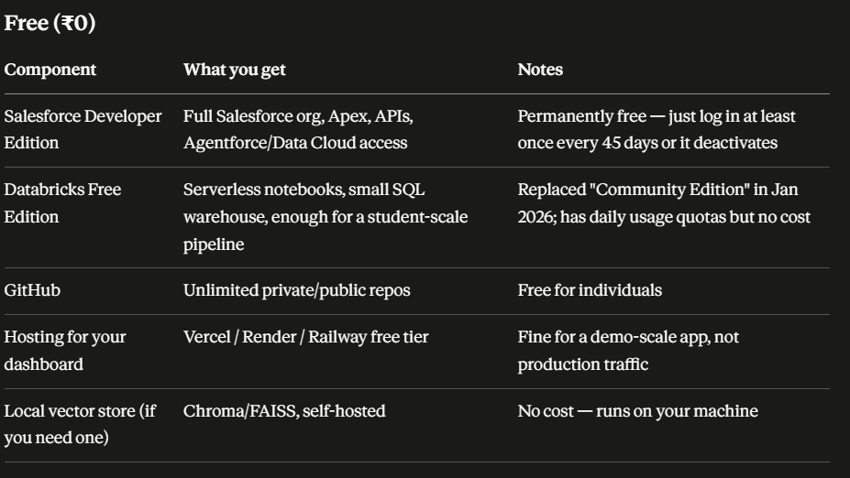

What about the data to test with? Where will I get it? What about Hubspot or other CRM tools?

Three real options here, and the honest answer is you'll mostly be building your own test data rather than finding it.
Option 1: Salesforce Developer Edition + synthetic data (recommended, matches your architecture)
The free Salesforce dev org comes essentially empty — no realistic hierarchy data by default. You'll need to seed it yourself, which is actually fine for Canon specifically, because your evaluation needs known ground truth anyway (you can't compute precision/recall on real messy data unless you already know what's wrong).
The approach: generate one canonical "true" org hierarchy (accounts, roles, territories, parent-child relationships) using a script — Python + Faker for realistic names/structure, sized to maybe 200-500 entities. Load that as your source of truth. Then fork it into two divergent copies:
- Copy A → loaded into Salesforce (via Data Loader or the API) as your "CRM" side
- Copy B → loaded into a Databricks table as your "warehouse" side, with deliberately injected conflicts (wrong parent on X%, stale territory on Y%, name variants, duplicate records, a few genuinely ambiguous edge cases)
Since you controlled the injection, you know exactly which pairs conflict and how — that's your gold-standard eval set, which is stronger for a paper than uncertain real data would be.
Option 2: HubSpot — genuinely easier for bulk test data
Worth knowing about even if you stick with Salesforce: HubSpot's free developer account gives you a test account, and its CLI has an hs test-account import-data command built specifically for bulk-loading your own CSVs of contacts/companies/deals straight into a test portal — no manual clicking, no Data Loader mapping files. If seeding Salesforce turns out to be more friction than you want, HubSpot's free CRM tier (the real, permanently-free product, not just the 90-day dev test account) is a legitimate swap-in for the "CRM side" of Canon, and arguably faster to get data into. One caveat: dev test accounts expire after 90 days of no API activity, so once you're actively building this won't bite you, but don't let it sit idle mid-semester.
Option 3: One real anonymized case study (worth pursuing in parallel)
Purely synthetic data gets you a clean quantitative benchmark, but a paper is stronger if you can also show one real-world case study. Options, roughly in order of feasibility:
- A small business, nonprofit, or campus organization that uses Salesforce or HubSpot and would let you pull an anonymized export (strip names/emails, keep structure) — even 50-100 real messy records adds real-world credibility on top of your synthetic benchmark.
- Public org-chart or company-hierarchy datasets on Kaggle (search "company org chart dataset" or "employee hierarchy dataset") to seed realistic-shaped structure even if you still inject conflicts yourself.
One important flag: don't use real Aviso data or anything from your day job for this, even anonymized. That's very likely a confidentiality/NDA violation regardless of good intent, and it's not worth the risk to a paper that doesn't need it — your synthetic ground-truth approach is actually the methodologically correct choice here, not a fallback.
My recommendation: build the synthetic generator first (this is maybe 2-3 days of work and gives you full control over your eval set), get Canon working end-to-end on that, and treat a real anonymized case study as a stretch goal for weeks 11-12 if time allows — not a blocker for the core build.

HOW IT WORKS?

